2014 Stock Market Data

2015 Stock Market Data

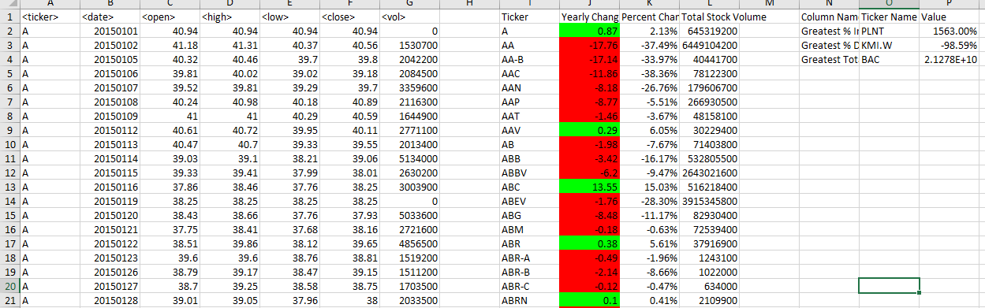

2016 Stock Market Data

